Frequency modification on the TD-L1550:
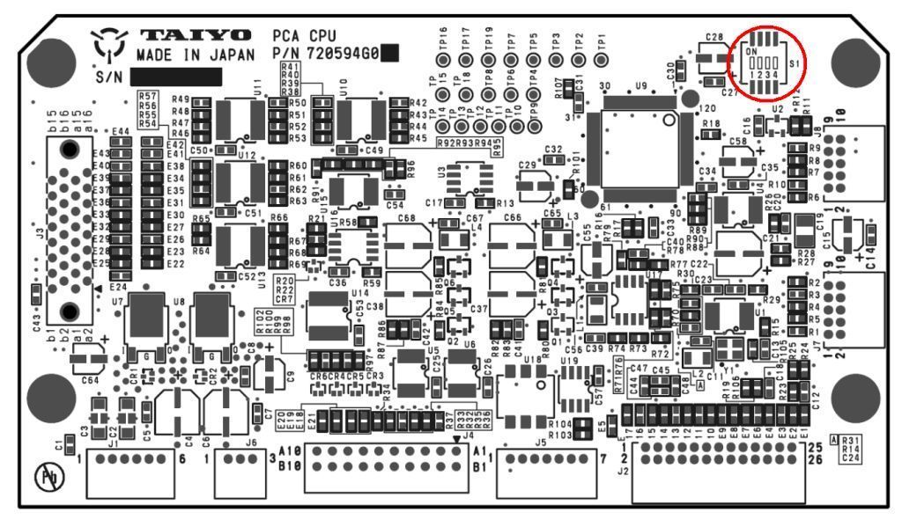Basically, regular TD-L1550A does not have the channel for 121.65 MHz.
However, we have special purpose TD-L1550A, called TD-L1550A-MOB.
TD-L1550A-MOB can detect 121.5 MHz basically, but for test mode of PLB, it is possible to detect 121.65 MHz.
In addition, the current available TD-L1550A can be converted from TD-L1550A to TD-L1550A-MOB and vice versa.
It is possible to switch regular TD-L1550A to TD-L1550A-MOB or vice versa by DIP switch S1-1 on PCA CPU. Regular TD-L1550A is "ON" and TD-L1550A-MOB shall be "OFF" position on S1-1 DIP switch. After changing the main unit to TD-L1550A-MOB, turning on the power pressing a numeral key, "8". Then, "E1" is displayed on the channel. That means that the unit can DF for 121.65 MHz only. Please find attached file for the position of S1-1 DIP switch on PCA CPU.

